Point-of-Sale (POS) Payment System
# Source: Chatgpt (GPT-5-Mini) at [1/21/2026]
A Point-of-Sale (POS) payment system is the combination of hardware and software used by merchants to accept payments at the time and place of a sale — typically in a retail store, restaurant, or service location.
It allows customers to pay using various methods like cash, cards, mobile wallets, or QR codes.

🧩 Main Components of a POS System
# Source: Chatgpt (GPT-5-Mini) at [1/21/2026]
- POS Terminal or Device
  - A physical machine (tablet, computer, or dedicated device) to input and process transactions.
- Card Reader or NFC Reader
  - For reading magnetic stripe, chip (EMV), or contactless cards (tap-to-pay).
- Software (POS App)
  - Handles billing, product management, pricing, tax, and reporting.
- Receipt Printer / Email/SMS Receipt
  - Prints or sends proof of payment.
- Cash Drawer (optional)
  - For storing physical cash in hybrid systems.

💳 Payment Methods Supported
# Source: Chatgpt (GPT-5-Mini) at [1/21/2026]
- Debit/Credit Cards
- Contactless Cards (NFC)
- Mobile Wallets (e.g., Apple Pay, Google Pay)
- QR Code Scanning
- Cash (in hybrid POS setups)

🏪 Where POS Systems Are Used
# Source: Chatgpt (GPT-5-Mini) at [1/21/2026]
- Retail stores
- Supermarkets
- Restaurants and cafes
- Pharmacies
- Hotels and salons

✅ Advantages
# Source: Chatgpt (GPT-5-Mini) at [1/21/2026]
- Fast and efficient transaction processing.
- Supports multiple payment options.
- Provides sales reports, inventory tracking, and customer data.
- Can be integrated with loyalty programs or online ordering.
- Enhances professionalism and customer experience.

🔴 Disadvantages
# Source: Chatgpt (GPT-5-Mini) at [1/21/2026]
- Requires electricity/internet (for cloud-based systems).
- May involve hardware and software costs.
- Susceptible to technical issues or downtime.
- Security risks if not properly configured.

📲 Types of POS Systems
# Source: Chatgpt (GPT-5-Mini) at [1/21/2026]
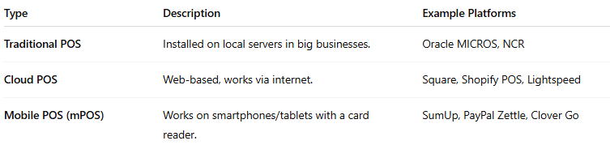

Type | Description | Example Platforms
Traditional POS | Installed on local servers in big businesses. | Oracle MICROS, NCR
Cloud POS | Web-based, works via internet. | Square, Shopify POS, Lightspeed
Mobile POS (mPOS) | Works on smartphones/tablets with a card reader. | SumUp, PayPal Zettle, Clover Go

